**Report**

**Strain study at Instron (30.11.2023).**

**CHAPTER 1- Investigating effect of changing clamp position with respect to sensor**

**Experiment’s conditions**

1. Instron
2. Disk 3 mm
3. Five positions of the clamping (Fig. 1)
4. Torque was applied clockwise
5. Sensors (Fig. 2): Sensor 1 and sensor 3 - gage factor 2.065; Sensor 2 – gage factor 2.095; gage resistance 120 Ohm; Vex source – internal; Vex value 2.5 V.
6. Torque range 10, 20, 30 Nm
7. Port 0 - Strain 0 (information in DAQ system) - Sensor 1

Port 1 - Strain 1 - Sensor 2

Port 2 – Strain 2 - Sensor 3

1. Data file (column 1 - Sensor 1; column 2 - Sensor 2; column 3 - Sensor 3)
2. LabView 2009
3. ¼ quarter bridge I for each sensor

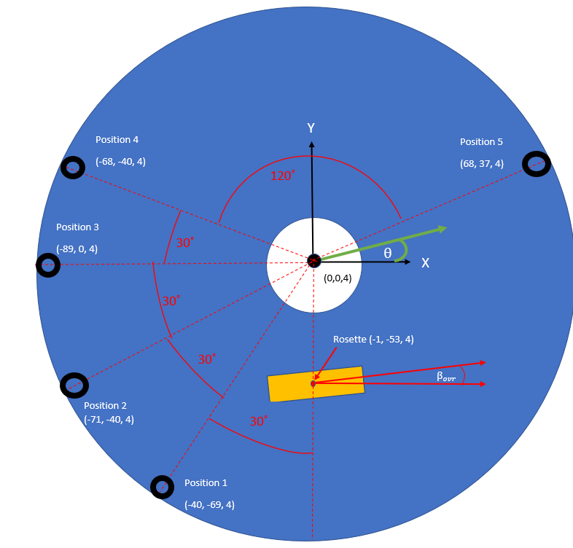

**Fig. 1.** Sketch (Five clamping positions)

Black circles = washer positions. Washer centre locations are given in the coordinates below. It was difficult to determine the positions of the washers on the bottom surface. As such, the bottom surface is assumed to have washers at the same coordinates, just at Z=0.

The clamped positions are arranged roughly as follows (exact values will be used in calculations)

*Position 1:* -30 degrees to rosette

*Position 2:* -60 degrees to rosette

*Position 3: -*90 degrees to rosette

*Position 4:* -120 degrees to rosette

*Position 5: -*240 degrees to rosette

(0,0,0) is located at centre of bottom surface of disc

(0,0,3) is located at centre of top surface of disc

= 50.5 degrees

= 95 degrees

= 140 degrees

= 5.5 degrees

**Fig. 2**. Rosette sensors

**POSITION 1**

Fig. 3. Experimental results for Sensor 1

Fig. 4. Experimental results for Sensor 2

Fig. 5. Experimental results for Sensor 3

**Table 1**

|  |  |  |  |
| --- | --- | --- | --- |
|  | **Sensor 1** | | |
| **The torque applied** | **10 Nm** | **20 Nm** | **30 Nm** |
| Idle level | -4.30x10-6 | -4.26x10-6 | -1.01x10-7 |
| Work level | 1.84x10-5 | 8.83x10-7 | -8.53x10-7 |
| Difference, numerical value | 6.14x10-6 | 5.14x10-6 | 9.247x10-6 |
|  | **Sensor 2** | | |
| **The torque applied** | **10 Nm** | **20 Nm** | **30 Nm** |
| Idle level | -9.18x10-6 | -1.19x10-5 | -2.97x10-6 |
| Work level | -9.71x10-6 | -3.22x10-5 | -5.51x10-5 |
| Difference, numerical value | 0.53x10-6 | 20.3x10-6 | 25.4x10-6 |
|  | **Sensor 3** | | |
| **The torque applied** | **10 Nm** | **20 Nm** | **30 Nm** |
| Idle level | -9.85x10-6 | -9.70x10-6 | -6.04x10-6 |
| Work level | -1.36x10-5 | -1.09x10-5 | -1.07x10-5 |
| Difference, numerical value | 3.75x10-6 | 1.2x10-6 | 4.66x10-6 |

**Table 2**

|  |  |  |  |  |
| --- | --- | --- | --- | --- |
| **The torque applied** | 10 | 20 | 20 | 30 |
|  | **Sensor 1** | | | |
| Δ Strain | - | | 4.107x10-6 | |
| Δ Torque, Nm | - | | 10 | |
| S | - | | 0.41x10-6 | |
|  | **Sensor 2** | | | |
| Δ Strain | 19.77x10-6 | | 5.1x10-6 | |
| Δ Torque, Nm | 10 | | 10 | |
| S | 1.98x10-6 | | 0.51x10-6 | |
|  | **Sensor 3** | | | |
| Δ Strain | - | | 3.46x10-6 | |
| Δ Torque, Nm | - | | 10 | |
| S | - | | 0.347x10-6 | |

The sensitivities for all sensors are almost the same. **The most sensitive sensor in Position 1 – Sensor 2**.

**POSITION 2**

Fig. 6. Experimental results for Sensor 1

Fig. 7. Experimental results for Sensor 2

Fig. 8. Experimental results for Sensor 3

**Table 3**

|  |  |  |  |
| --- | --- | --- | --- |
|  | **Sensor 1** | | |
| **The torque applied** | **10 Nm** | **20 Nm** | **30 Nm** |
| Idle level | -4.19x10-6 | -9.68x10-6 | -1.38x10-6 |
| Work level | -7.60x10-6 | -3.03x10-5 | -4.79x10-5 |
| Difference, numerical value | 3.41x10-6 | 20.62x10-6 | 46.52x10-6 |
|  | **Sensor 2** | | |
| **The torque applied** | **10 Nm** | **20 Nm** | **30 Nm** |
| Idle level | -9.71x10-6 | -1.19x10-5 | -9.67x10-6 |
| Work level | -1.27x10-5 | -2.18x10-5 | -2.81x10-5 |
| Difference, numerical value | 2.99x10-6 | 9.99x10-6 | 18.48x10-6 |
|  | **Sensor 3** | | |
| **The torque applied** | **10 Nm** | **20 Nm** | **30 Nm** |
| Idle level | -9.42x10-6 | -7.82x10-6 | -8.67x10-6 |
| Work level | -8.94x10-6 | -3.88x10-6 | 1.27x10-6 |
| Difference, numerical value | 0.48x10-6 | 3.94x10-6 | 7.4x10-6 |

**Table 4**

|  |  |  |  |  |
| --- | --- | --- | --- | --- |
| **The torque applied** | 10 | 20 | 20 | 30 |
|  | **Sensor 1** | | | |
| Δ Strain | 17.21x10-6 | | 25.9x10-6 | |
| Δ Torque, Nm | 10 | | 10 | |
| S | 1.721x10-6 | | 2.59x10-6 | |
|  | **Sensor 2** | | | |
| Δ Strain | 7x10-6 | | 8.49x10-6 | |
| Δ Torque, Nm | 10 | | 10 | |
| S | 0.7x10-6 | | 0.849x10-6 | |
|  | **Sensor 3** | | | |
| Δ Strain | 3.46x10-6 | | 3.46x10-6 | |
| Δ Torque, Nm | 10 | | 10 | |
| S | 0.346x10-6 | | 0.346x10-6 | |

**The most sensitive sensor in Position 2 – Sensor 1**

**POSITION 3**

Fig. 9. Experimental results for Sensor 1

Fig. 10. Experimental results for Sensor 2

Fig. 10. Experimental results for Sensor 3

**Table 5**

|  |  |  |  |
| --- | --- | --- | --- |
|  | **Sensor 1** | | |
| **The torque applied** | **10 Nm** | **20 Nm** | **30 Nm** |
| Idle level | -7.15x10-6 | -1.30x10-5 | -1.07x10-5 |
| Work level | -1.66x10-5 | -3.76x10-5 | -5.88x10-5 |
| Difference, numerical value | 9.45x10-6 | 24.6x10-5 | 48.1x10-6 |
|  | **Sensor 2** | | |
| **The torque applied** | **10 Nm** | **20 Nm** | **30 Nm** |
| Idle level | -9.95x10-6 | -8.74x10-6 | -8.60x10-6 |
| Work level | -9.88x10-6 | -8.35x10-6 | -5.61x10-6 |
| Difference, numerical value | 0.07x10-6 | 0.39x10-6 | 2.99x10-6 |
|  | **Sensor 3** | | |
| **The torque applied** | **10 Nm** | **20 Nm** | **30 Nm** |
| Idle level | -9.14x10-6 | -6.89x10-6 | -7.31x10-6 |
| Work level | -7.98x10-6 | -4.80x10-6 | -1.88x10-6 |
| Difference, numerical value | 1.16x10-6 | 2.09x10-6 | 5.43x10-6 |

**Table 6**

|  |  |  |  |  |
| --- | --- | --- | --- | --- |
| **The torque applied** | 10 | 20 | 20 | 30 |
|  | **Sensor 1** | | | |
| Δ Strain | 15.15x10-6 | | 23.5x10-6 | |
| Δ Torque, Nm | 10 | | 10 | |
| S | 1.515x10-6 | | 2.35x10-6 | |
|  | **Sensor 2** | | | |
| Δ Strain | 0.32x10-6 | | 2.6x10-6 | |
| Δ Torque, Nm | 10 | | 10 | |
| S | 0.032x10-6 | | 0.26x10-6 | |
|  | **Sensor 3** | | | |
| Δ Strain | 0.93x10-6 | | 3.34x10-6 | |
| Δ Torque, Nm | 10 | | 10 | |
| S | 0.093x10-6 | | 0.334x10-6 | |

**The most sensitive sensor in Position 3 – Sensor 1**

**POSITION 4**

Fig. 11. Experimental results for Sensor 1

Fig. 12. Experimental results for Sensor 2

Fig. 13. Experimental results for Sensor 3

**Table 7**

|  |  |  |  |
| --- | --- | --- | --- |
|  | **Sensor 1** | | |
| **The torque applied** | **10 Nm** | **20 Nm** | **30 Nm** |
| Idle level | -1.15x10-6 | -1.13x10-5 | -1.11x10-5 |
| Work level | -1.50x10-5 | -9.06x10-5 | -1.66x10-4 |
| Difference, numerical value | 3.5x10-6 | 79x10-6 | 154x10-6 |
|  | **Sensor 2** | | |
| **The torque applied** | **10 Nm** | **20 Nm** | **30 Nm** |
| Idle level | -1.13x10-5 | -1.08x10-6 | -1.04x10-5 |
| Work level | -1.01x10-5 | -2.59x10-5 | -4.04x10-5 |
| Difference, numerical value | 1.2x10-6 | 15.1x10-5 | 30x10-6 |
|  | **Sensor 3** | | |
| **The torque applied** | **10 Nm** | **20 Nm** | **30 Nm** |
| Idle level | -1.08x10-5 | -1.01x10-5 | -9.77x10-6 |
| Work level | -1.08x10-5 | 2.30x10-7 | 1.34x10-5 |
| Difference, numerical value | 0 | 10.33x10-6 | 23.17x10-6 |

**Table 8**

|  |  |  |  |  |
| --- | --- | --- | --- | --- |
| **The torque applied** | 10 | 20 | 20 | 30 |
|  | **Sensor 1** | | | |
| Δ Strain | 75.5x10-6 | | 75x10-6 | |
| Δ Torque, Nm | 10 | | 10 | |
| S | 7.55x10-6 | | 7.5x10-6 | |
|  | **Sensor 2** | | | |
| Δ Strain | 13.9x10-6 | | 14.9x10-6 | |
| Δ Torque, Nm | 10 | | 10 | |
| S | 1.39x10-6 | | 1.49x10-6 | |
|  | **Sensor 3** | | | |
| Δ Strain | 10.33x10-6 | | 12.84x10-6 | |
| Δ Torque, Nm | 10 | | 10 | |
| S | 1.033x10-6 | | 1.284x10-6 | |

**The most sensitive sensor in Position 4 – Sensor 1**

**POSITION 5**

Fig. 14. Experimental results for Sensor 1

Fig. 15. Experimental results for Sensor 3

Fig. 16. Experimental results for Sensor 3

**Table 9**

|  |  |  |  |
| --- | --- | --- | --- |
|  | **Sensor 1** | | |
| **The torque applied** | **10 Nm** | **20 Nm** | **30 Nm** |
| Idle level | -7.86x10-6 | -7.95x10-6 | -8.63x10-6 |
| Work level | -8.12x10-6 | -8.78x10-6 | -9.75x10-6 |
| Difference, numerical value | 0.26x10-6 | 0.83x10-6 | 1.12x10-6 |
|  | **Sensor 2** | | |
| **The torque applied** | **10 Nm** | **20 Nm** | **30 Nm** |
| Idle level | -1.01x10-5 | -1.03x10-5 | -1.06x10-5 |
| Work level | -1.04x10-5 | -1.11x10-5 | -1.22x10-5 |
| Difference, numerical value | 0.3x10-7 | 0.8x10-6 | 1.6x10-6 |
|  | **Sensor 3** | | |
| **The torque applied** | **10 Nm** | **20 Nm** | **30 Nm** |
| Idle level | -9.96x10-6 | -3.61x10-6 | -1.17x10-6 |
| Work level | -4.47x10-6 | 1.17x10-5 | 2.71x10-5 |
| Difference, numerical value | 5.49x10-6 | 15.31x10-6 | 28.27x10-6 |

**Table 10**

|  |  |  |  |  |
| --- | --- | --- | --- | --- |
| **The torque applied** | 10 | 20 | 20 | 30 |
|  | **Sensor 1** | | | |
| Δ Strain | 0.57x10-6 | | 0.29x10-6 | |
| Δ Torque, Nm | 10 | | 10 | |
| S | 0.057x10-6 | | 0.029x10-6 | |
|  | **Sensor 2** | | | |
| Δ Strain | 0.5x10-6 | | 0.8x10-6 | |
| Δ Torque, Nm | 10 | | 10 | |
| S | 0.05x10-6 | | 0.08x10-6 | |
|  | **Sensor 3** | | | |
| Δ Strain | 9.82x10-6 | | 12.96x10-6 | |
| Δ Torque, Nm | 10 | | 10 | |
| S | 0.982x10-6 | | 1.296x10-6 | |

**The most sensitive sensor in Position 5 – Sensor 3**

**Comparing strain in sensors for different positions on same graph**

**Sensor 1:**

* Tensile strain when clamp at position 1 and position 5.
* Compressive strain when clamp at position 2, position 3, and position 4

Fig. 17. Experimental results for Sensor 1 at 30 Nm

**Sensor 2:**

* Tensile strain when clamp at position 3.
* Compressive strain when clamp at position 1, position 2, position 4, and position 5.

Fig. 18. Experimental results for Sensor 2 at 30 Nm

**Sensor** **3:**

* Tensile strain when clamp at position 2, 3, 4, 5.
* Compressive strain when clamp at position 1.

Fig. 19. Experimental results for Sensor 3 at 30 Nm

**Conclusions**

1. With increasing torque, the level of the useful Strain signal (including idle speed) increases for all sensors and in all positions. With the exception of Position 1 for Sensor 1 and Sensor 3 (it is difficult to find the stable loading level, the idle level has shifted after unloading)

2. The Strain type differs from each other both within the study of the behavior of one sensor in different positions, and when studying the behavior of different sensors within the same position.

3. **Position 1**. The most sensitive sensor is Sensor 2. But at the same time, all sensitivities for all three sensors are approximately the same.

**Position 2.** The most sensitive sensor is **Sensor 1**. The sensitivity of sensor 1 is 3 times greater than that of sensor 2, and 7.5 times greater than that of sensor 3.

**Position 3.** The most sensitive sensor is **Sensor 1.** The sensitivity of sensor 1 is 9 times greater than that of sensor 2, and 7 times greater than that of sensor 3.

**Position 4.** The most sensitive sensor is **Sensor 1.** The sensitivity of sensor 1 is 5 times greater than that of sensor 2, and 5.9 times greater than that of sensor 3.

**Position 5**. The most sensitive sensor is **Sensor 3.** The sensitivity of sensor 1 is 44 times greater than that of sensor 1, and 16.2 times greater than that of sensor 2.

4. The most sensitive position for **Sensor 1** is **Position 4** (Fig. 17). In this case, the largest increase in the useful Strain signal is observed. For sensor 1, tensile strains can be observed for positions 1 and 5; compressive strains for positions 2, 3 and 4.

5. The noise level is significant at all torque values. With an applied torque of 10 Nm and 20 Nm, the noise level is commensurate with the increase in the level of the useful signal compared to idle. Therefore, when comparing, it is necessary to smooth out the curves.

6. Sometimes for a moment of 10 Nm and 20 Nm it is difficult to determine the stages of the cycle (idling, loading, unloading). And in position 5 for sensors 1 and 2 it is impossible to determine the stages of the working cycle. This can only be done for sensor 3.

Position 4

2

3

1

